

**Mini Project Report**

on

**Car Rental Database Management System**

**Project Members:**

ALOK RAJ 13

SAEED SERAJ AHMED 15

SIDDHI DINGORKAR 21

MAHI BOHARA 29

**Under the Guidance of**

**Sheetal Girase**

**School of Computer Engineering and Technology**

**MIT World Peace University, Kothrud,**

**Pune 411 038, Maharashtra – India**

**2022-2023**

**Problem Statement:**

The management of the rental process has become more challenging as the car rental business has grown consistently over the years. Car rental businesses must manage a sizable fleet of vehicles, ensure their upkeep, handle reservations and cancellations, and give customers timely and accurate billing information, among other challenges.

Another problem is managing the real-time availability of cars, particularly during busy times of year. To satisfy customer demand, car rental companies must make sure they have the appropriate number of vehicles available at the appropriate time. Without real-time data, managing inventory becomes challenging, and businesses risk turning away prospective customers or overbooking, which would result in dissatisfied clients.

**Introduction:**

Car hire services are now a necessary component of travel in the modern world. Managing a car rental business has become difficult due to the rising demand for rental cars. Our team has developed a car rental database management system to address these issues and will assist rental car businesses in effectively managing their fleet, clients, reservations, and payments.

Based on make and model, the customer can rent a vehicle through our system. Our system gives customers various features, and if the rental car is returned after the scheduled return time and date, a late fee will be assessed.

Technologies Used:

**SQL:**

Originally based upon relational algebra and tuple relational calculus, SQL consists of a data definition language, data manipulation language, and data control language. The scope of SQL includes data insert, query, update and delete, schema creation and modification, and data access control. Although SQL is often described as, and to a great extent is, a declarative language (4GL), it also includes procedural elements.

**PHP:**

PHP is a server-side scripting language designed primarily for web development but also used as a general-purpose programming language. It now stands for the recursive acronym PHP: Hypertext Preprocessor.

PHP code may be embedded into HTML or HTML5 markup, or it can be used in combination with various web template systems, web content management systems and web frameworks. The web server software combines the results of the interpreted and executed PHP code, which may be any type of data, including images, with the generated web page.

**XAMPP:**

Xampp is a free and open-source cross platform web server solution stack package developed by Apache Friends, consisting mainly of the Apache HTTP Server, MariaDB database, and interpreters for scripts written in the PHP and Perl programming languages. XAMPP stands for Cross-Platform (X), Apache (A), MariaDB (M), PHP (P) and Perl (P). It is a simple, lightweight Apache distribution that makes it extremely easy for developers to create a local web server for testing and deployment purposes. Everything needed to set up a web server application (Apache), database (MariaDB), and scripting language (PHP) - is included in an extractable file.

**CSS:**

CSS stands for Cascading Style Sheets. It is the language for describing the presentation of Web pages, including colors, layout, and fonts, thus making our web pages presentable to the users. CSS describes how HTML elements are to be displayed on screen, paper, or in other media.CSS saves a lot of work. It can control the layout of multiple web pages all at once.

**ER Diagram:**

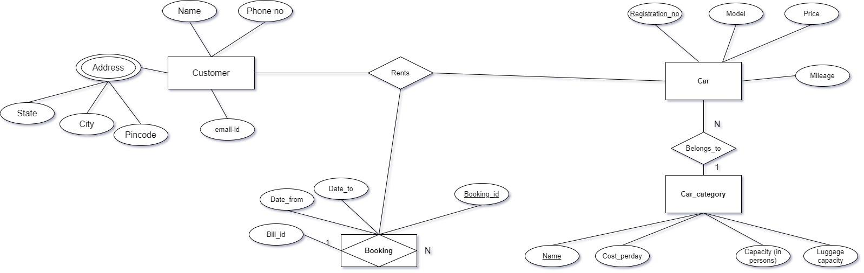

**Schema Diagram:**

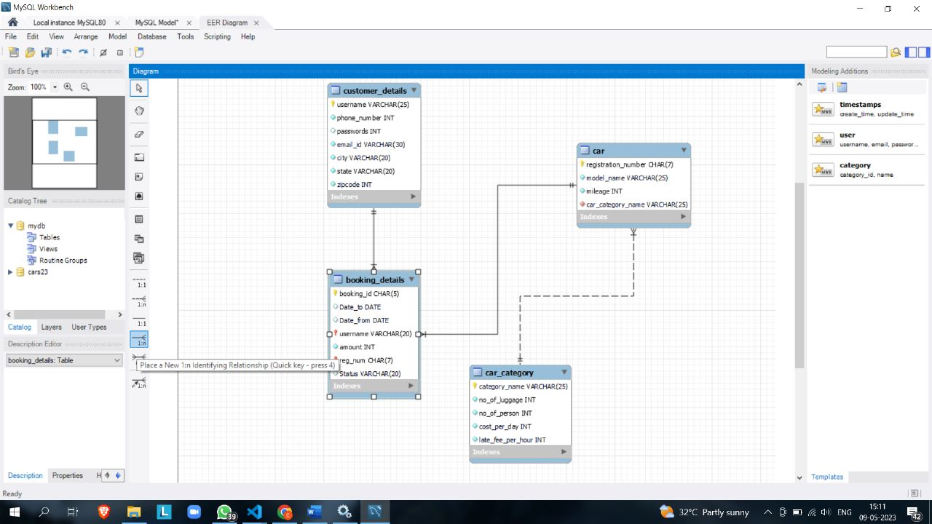

**DML Script:**

create database Cars23;

use Cars23;

create table customer_details

(

username varchar(25) not null primary key,

phone_number int not null,

passwords int,

email_id varchar(30) not null,

city varchar(20) not null,

state varchar(20) not null,

zipcode int not null

);

create table car_category

( category_name varchar(25) not null primary key,

no_of_luggage int not null,

no_of_person int not null,

cost_per_day int not null,

late_fee_per_hour int not null

);

create table car

( registration_number char(7) not null primary key,

model_name varchar(25) not null,

mileage int not null,

car_category_name varchar(25) not null,

foreign key (car_category_name) references car_category(category_name)

);

create table booking_details

( booking_id char(5) not null,

Date_to date,

Date_from date,

username varchar(20),

amount int not null,

reg_num char(7) not null,

Status varchar(20),

foreign key (reg_num) references car(registration_number),

foreign key (username) references customer_details(username),

primary key(booking_id,reg_num,username));

**Front End Screenshots**

**Admin Page:**

1. Updation on Users:

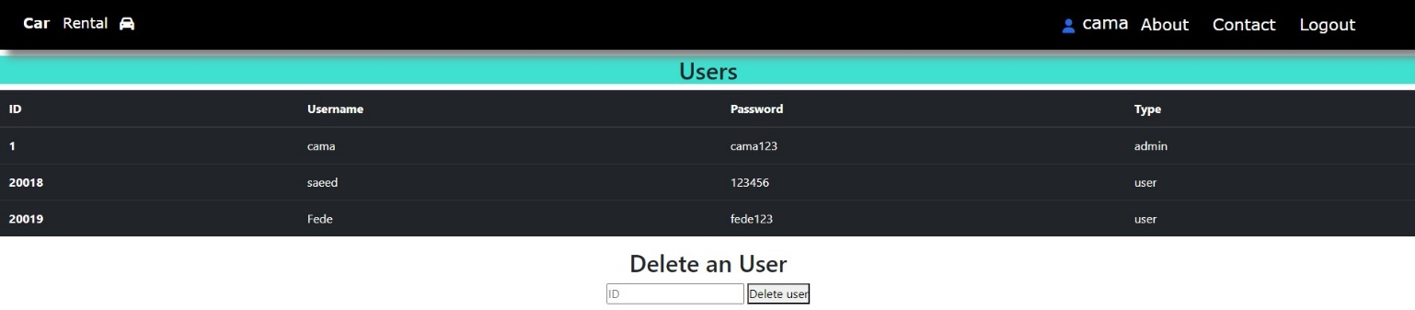

2. Updation on Cars:

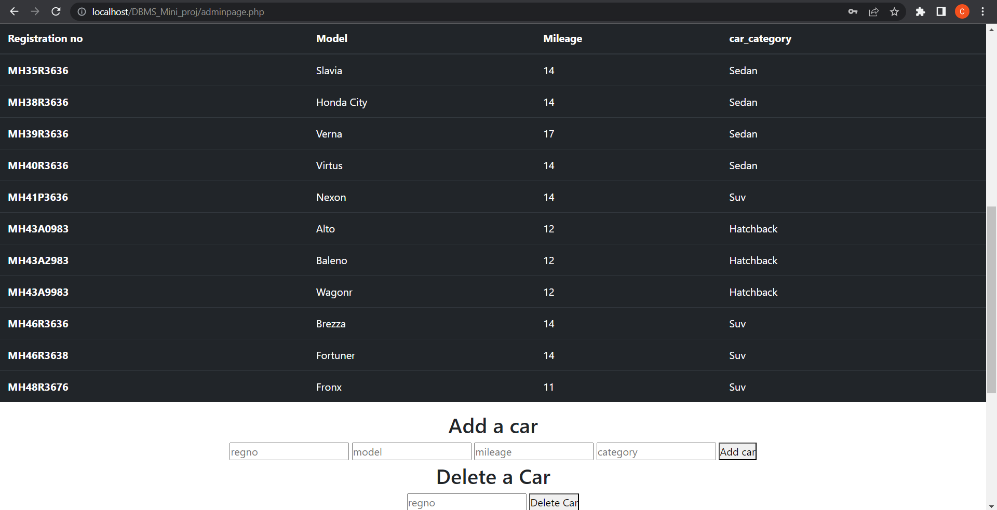3. Updation on bookings for car return

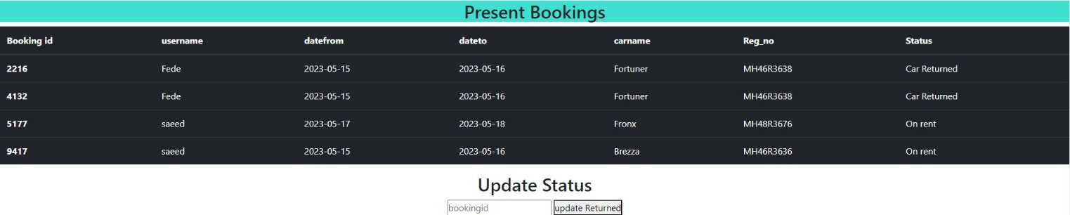**User Page:**

1. Login Page

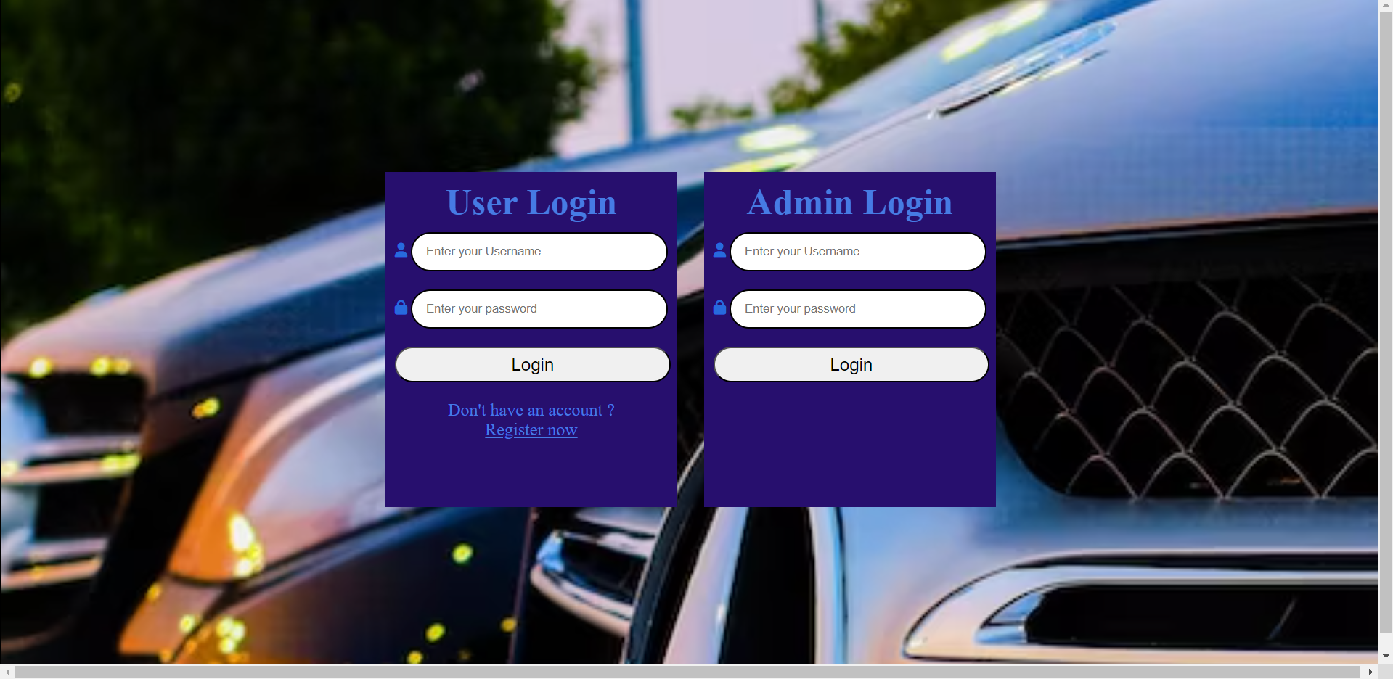

2.Main Webpage

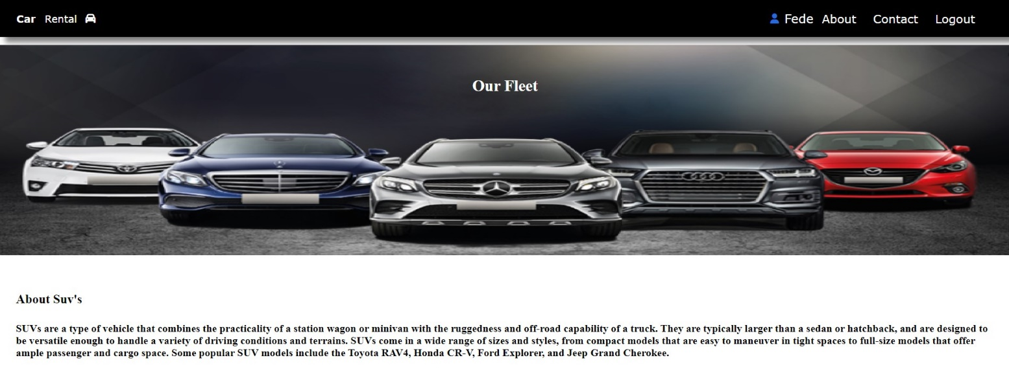

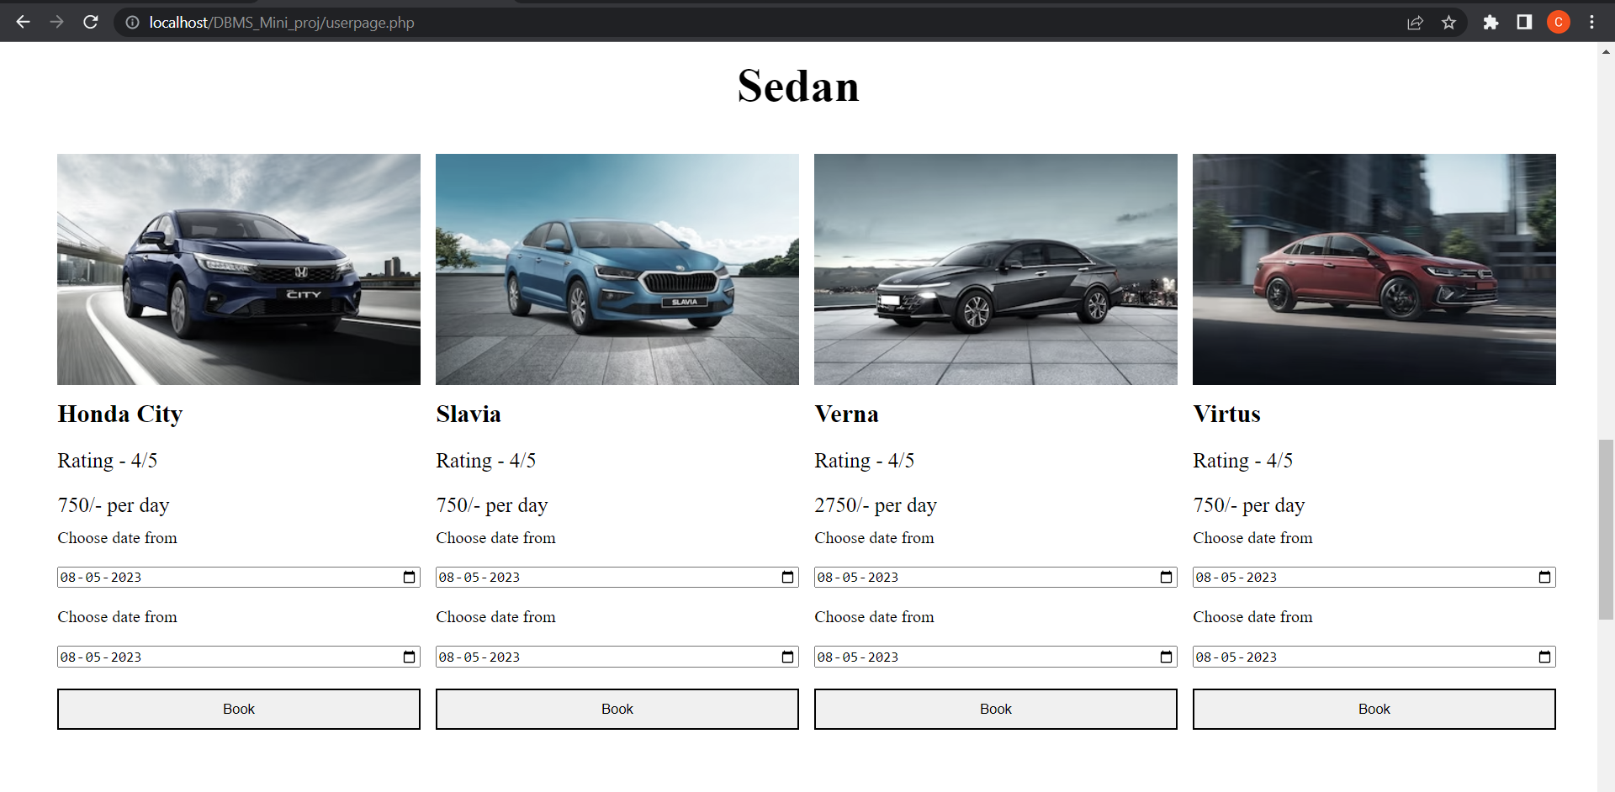

Payment Page

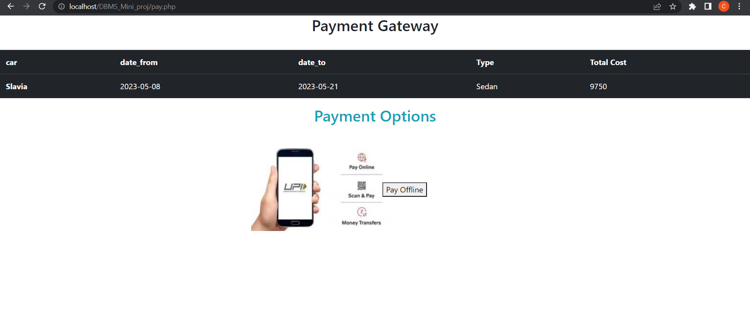

Backend Screenshots:

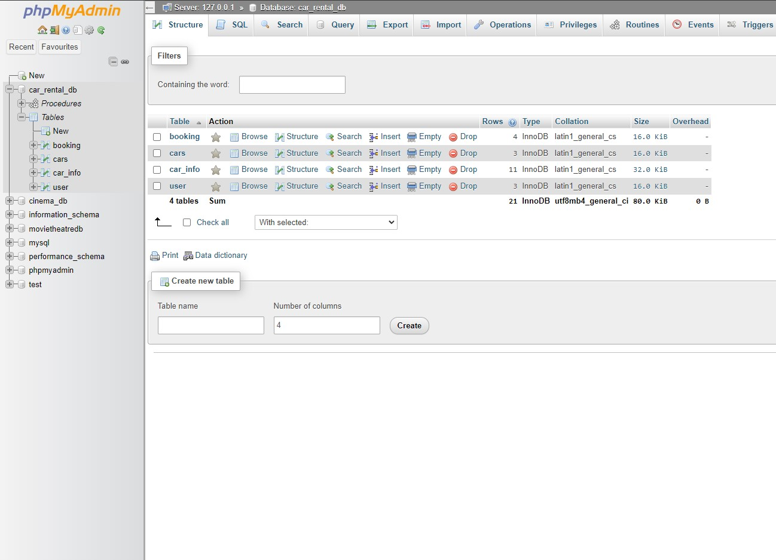

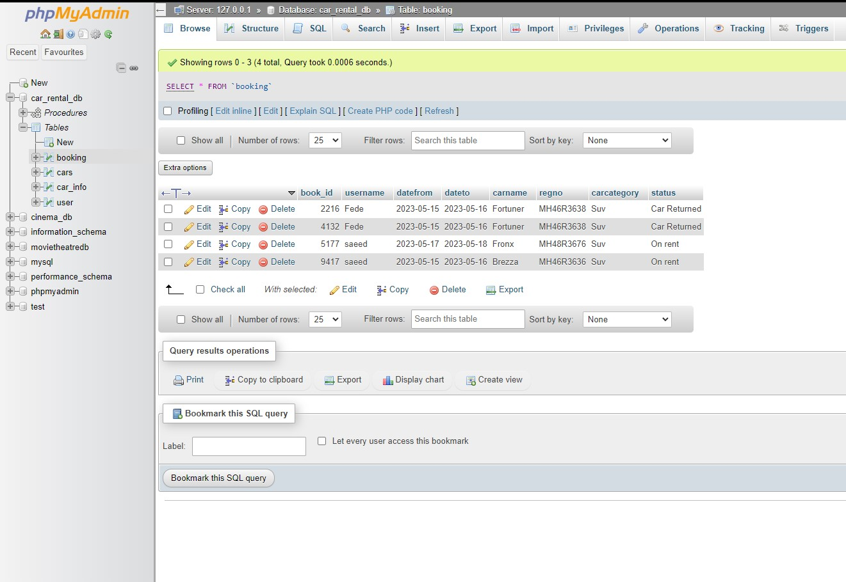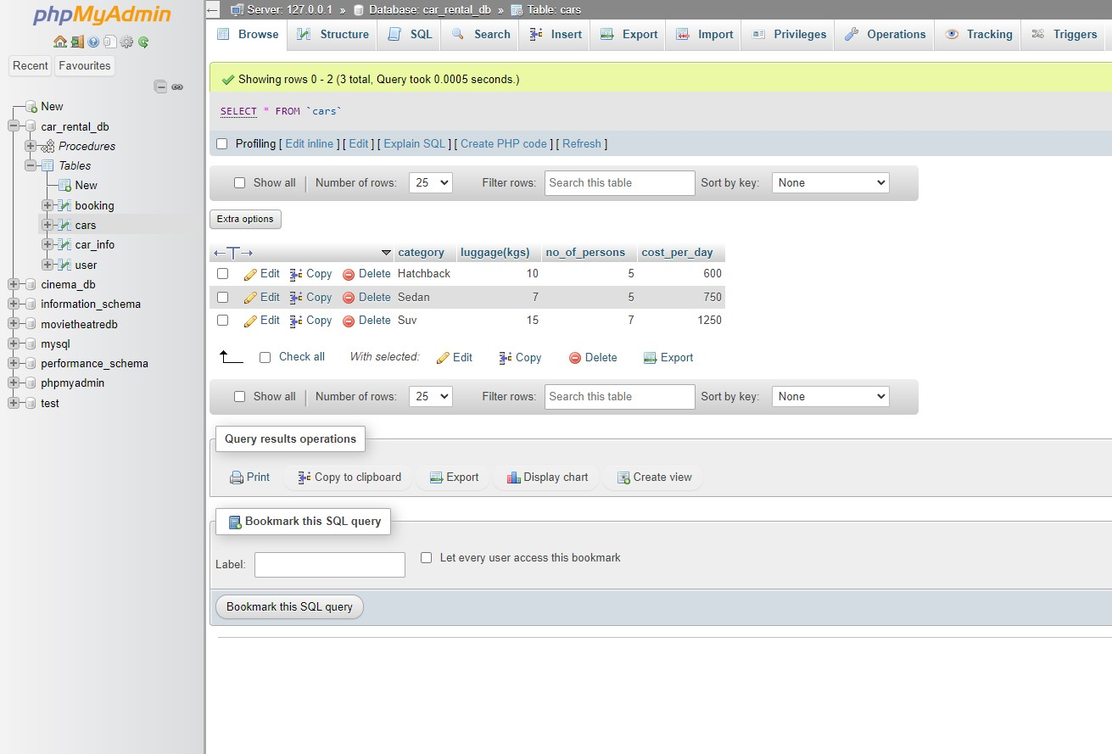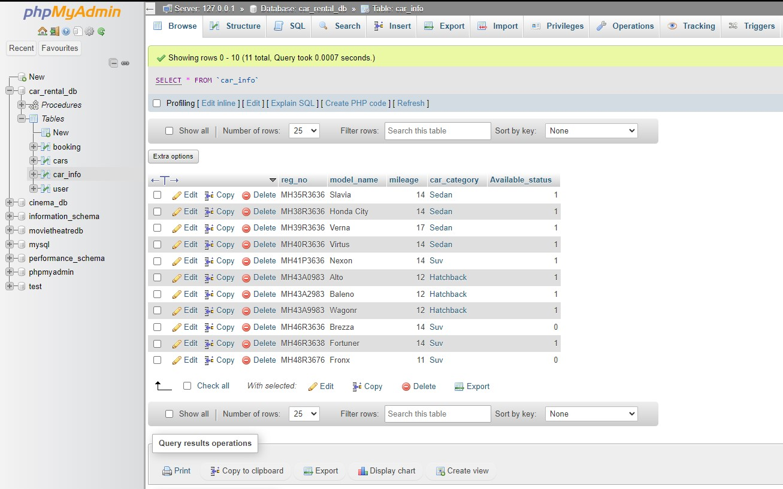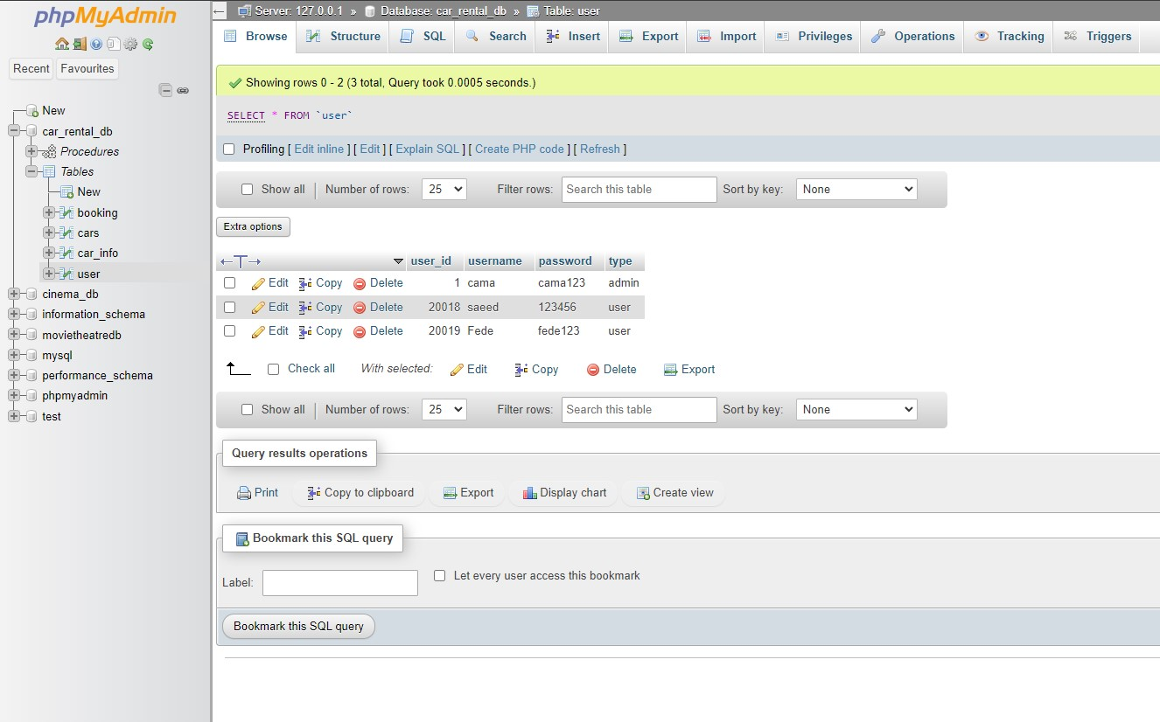

**Summary**

In summary, our database management system for the car rental industry has been successfully developed and implemented. It includes a user-friendly interface, comprehensive database, and a strong focus on security and scalability.

**Conclusion**

In conclusion, the development of our car rental system has been a great success. We have implemented a robust and reliable database management system that enables our users to rent cars seamlessly and efficiently.

Customers can utilize our system's user-friendly interface to browse and reserve cars online, manage their reservations, and send payments. The system also features an extensive database where vital data about clients, vehicles, and rentals is kept.

Overall, the way vehicle rental companies run their businesses has significantly improved thanks to our method for renting cars. Our business has been able to boost revenue, enhance client happiness, and optimize our rental operations thanks to it.

We are dedicated to constantly enhancing and modernizing our system as technology advances in order to maintain our position as a leader in the automobile rental sector. We think that for many years to come, our database management system will be crucial to our success.